Template for Extended Abstracts for International Seminar of Science and Applied Technology (ISSAT) 2020

First A. Author*1, Second B. Author2 and Third C. Author3

1, 2 Authors’ Department, Institute, Organisation, Country

(E-mail: [firstauthorsname@aaaa.bbb](mailto:firstauthorsname@aaaa.bbb), secondauthorsname@aaaa.bbb)

3 Author’s Department, Institute, Organisation, Country

(E-mail: thirdauthorsname@aaaa.bbb)

***Abstract:*** Abstract should be written with 10 font size, Times New Roman, single line spacing. The abstract should be concise and should contain no more than 300 words

***Keywords*:**This section should contain maximum 5 words separated by commas.

**EXTENDED ABSTRACT**

This document presents the instructions needed to prepare the extended abstract (1000-1500 words in length including references) to be included in the proceedings of the ISSAT 2020.

The title (14 point, bold), authors’ names (12 point), and affiliations (10 point) should be set flush-centre. Please leave one blank line (12 point) after the title as well as after the list of authors.

All abstracts should be written in English. In order to achieve graphical consistency, the extended abstract should be written using Microsoft Word. It should be A4 size paper with margin 1.5 cm on all side in MS Word format in 12 points New Times Roman type single line spacing.

The body text itself should be left and right justified. The extended abstract should contain the following sections**: Should include Introduction, Objectives, Methodology, Results, Discussion/Conclusion, and Recommendations with related references,** with each section headline written with Times New Roman font, 12 font size, bold, and all caps. These sections can be named differently and subsections can be included. The extended abstract can contain figures, tables and images. Pages should not be numbered.

Authors are requested to submit Abstracts via Edas Conference Management ISSAT-E Submission system at <http://edas.info/N27299> for Engineering articles and ISSAT-S Submission system at <http://edas.info/N27300> for Social Humanities articles. Accepted formats is MS Word.

Supporting figures, tables and images may be included. All the tables, images and figures should be centered. Figures and images should be numbered and figure captions should be placed under the figure or image. Please see Figure 1 for an example. The tables should also be numbered and the table caption should be placed at the top. Please see Table 1 for an example.

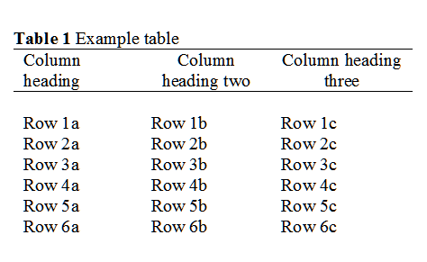

Table 1: Example Table



**Figure 1.** Example graph for the extended abstract.

# REFERENCES

References that have been presented inside (Auhtors, Year) in the full text should be prepared in the format of APA 6th as shown below:

[1] James, H. (1937). The ambassadors. New York, NY: Scribner.

[2] Smith, T., Jones, M.: 'The title of the paper', IET Syst. Biol., 2007, 1, (2), pp. 1–7

[3] Borwn, L., Thomas, H., James, C., et al.:'The title of the paper, IET Communications, 2012, 6, (5), pp 125-138

[4] Hodges, A., Smith, N.: 'The title of the book chapter', in Brown, S. (Ed.): 'Handbook of Systems Biology' (IEE Press, 2004, 1st edn.), pp. 1–7